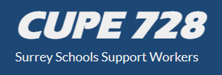
Member Meeting Dates

General Membership Meetings are for each CUPE728 member, regardless if you are a new employee to SD36 or not. The following dates will be our membership meeting. Currently, meetings are both on-line or in person at the Surrey Beaver Athletics Association 17395 57th Avenue in Cloverdale. Please check out www.cupe728.ca to register for the meetings and more information

October 18, 2023 6pm.  November 15, 2023 at 8pm  December 20, 2023 at 6pm  January 17, 2024 at 8pm | February 21, 2024 at 6pm  April 3, 2023 at  April 17, 2024 – at 6 pm nominations for you 2024/2025 executive

